CSE470 - Software Engineering
Crypto World Bank: Agile Development Methodology
Course: CSE470 - Software Engineering
Project: Decentralized Crypto Reserve & Lending Bank
Duration: 2 Months (8 Weeks)
Methodology: Agile/Scrum
Sprints: 3 Sprints
Date: February 2026
Authors: Md. Bokhtiar Rahman Juboraz (20301138) • Md. Mahir Ahnaf Ahmed (20301083)

Contents
1 | Project Overview
2 | Sprint Structure
3 | Sprint 1: Foundation & Core Banking
4 | Sprint 2: Lending & Payment Features
5 | Sprint 3: Advanced Features & Security
6 | Agile Artifacts
7 | Team Roles & Responsibilities
8 | Risk Management
9 | Metrics & KPIs
10 | Communication Plan
11 | SDLC Stage Mapping
12 | Design Decisions and Alternatives Considered
13 | UML and Architecture
14 | Design Patterns
15 | Software Testing and Metrics
16 | Effort Estimation and Project Scheduling
17 | Conclusion

1. Project Overview
1.1 Project Scope
The Crypto World Bank is a decentralized lending platform built on blockchain technology with a hierarchical banking structure (World Bank → National Banks → Local Banks → Users). The system includes installment payments, AI/ML security layers, chat functionality, and comprehensive user management.
1.2 Development Methodology
Agile/Scrum Framework with the following characteristics:
• Sprint Duration: 2-3 weeks per sprint
• Team Size: 2 developers (thesis project)
• Weekly Sync: Progress review, blockers, planning (replaces daily standup for 2-person team)
• Sprint Planning: 1 hour at sprint start
• Sprint Review: 30 minutes at sprint end
• Retrospective: 30 minutes at sprint end

2. Sprint Structure
2.1 Overall Timeline
2.2 Sprint Breakdown
Sprint | Duration | Focus Area | Key Deliverables
**Sprint 1** | Weeks 1-3 | Foundation & Core Banking | Smart contracts, basic UI, wallet integration, database schema
**Sprint 2** | Weeks 4-6 | Lending, Payment & Communication | Loan requests, installments, borrowing limits, chat, income verification, bank hierarchy
**Sprint 3** | Weeks 7-8 | AI/ML Security, Testing & Finalization | AI/ML integration, risk dashboard, profiles, market data, testing, documentation

3. Sprint 1: Foundation & Core Banking
Duration: 3 Weeks (Weeks 1-3)
Sprint Goal: Establish core blockchain infrastructure and hierarchical banking structure
3.1 Sprint Backlog
Epic 1: Smart Contract Development (21 pts)
ID | Story | Pts
US-1.1 | World Bank contract — reserve management, national bank registration | 5
US-1.2 | National Bank contract — borrow from WB, lend to Local Banks | 5
US-1.3 | Local Bank contract — borrow from NB, lend to users | 5
US-1.4 | Role-based access control — WB/NB/LB Admin, Bank User, Borrower | 3
US-1.5 | Gas cost management — initiator pays; Polygon low-fee ($0.001–0.01/tx) | 3

Epic 2: Frontend Foundation (13 pts)
ID | Story | Pts
US-1.6 | Wallet connection — MetaMask, WalletConnect, Sepolia/Mumbai | 3
US-1.7 | Dashboard UI — Material Design 3, responsive, blockchain-themed | 5
US-1.8 | Navigation & layout — AppBar, role-based menu | 3
US-1.9 | Blockchain visual elements — tx hash, security badges | 2

Epic 3: Database Schema (8 pts)
ID | Story | Pts
US-1.10 | Database design — 15 tables, 3NF (see CSE370) | 5
US-1.11 | Migration scripts and seed data | 3

3.2 Sprint 1 Burndown
Total Story Points: 42
Team Velocity: ~21 points per week (estimated)
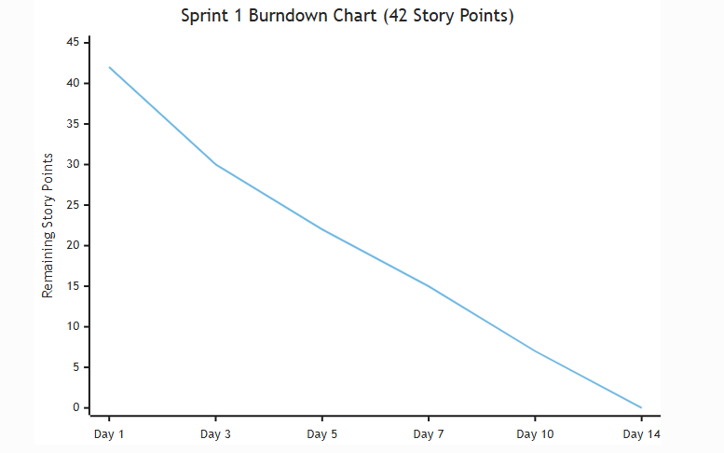
Day | Planned | Completed | Remaining
Day 1 | 0 | 0 | 42
Day 3 | 14 | 12 | 30
Day 5 | 21 | 20 | 22
Day 7 | 28 | 27 | 15
Day 10 | 35 | 35 | 7
Day 14 | 42 | 42 | 0

3.3 Sprint 1 Deliverables
• ✅ Smart contracts deployed on testnet
• ✅ Basic frontend with wallet connection
• ✅ Database schema implemented
• ✅ Role-based access control working
• ✅ Dashboard UI with blockchain elements

4. Sprint 2: Lending & Payment Features
Duration: 3 Weeks (Weeks 4-6)
Sprint Goal: Implement complete lending flow with installment payments and communication
4.1 Sprint Backlog
Epic 4: Loan Management (21 pts)
ID | Story | Pts
US-2.1 | Loan request — form, one per bank, on-chain storage | 5
US-2.2 | Loan approval/rejection — pending view, approver per bank | 5
US-2.3 | Income verification — file upload, document storage | 5
US-2.4 | Borrowing limit — 6mo/1yr calc, 3+ paid exception | 5
US-2.5 | Loan request visibility — hide after approval | 1

Epic 5: Installment Payment (13 pts)
ID | Story | Pts
US-2.6 | Installment logic — auto setup for ≥100 ETH, configurable count | 5
US-2.7 | Installment UI — list, pay button, confirmation | 5
US-2.8 | Deadline tracking — display, overdue warnings | 3

Epic 6: Chat System (13 pts)
ID | Story | Pts
US-2.9 | Borrower–bank chat — real-time, history, read/unread | 8
US-2.10 | Chat notifications — in-app, unread count | 5

Epic 7: Profile Management (8 pts)
ID | Story | Pts
US-2.11 | Profile pages — all user types, role-specific | 5
US-2.12 | Terms and conditions — view, acceptance tracking | 3

Epic 7b: QR Code System (3 pts)
ID | Story | Pts
US-2.13 | QR generation & scan — wallet, loan URL, contract address | 3

4.2 Sprint 2 Burndown
Total Story Points: 58
Team Velocity: ~27 points per week (estimated)
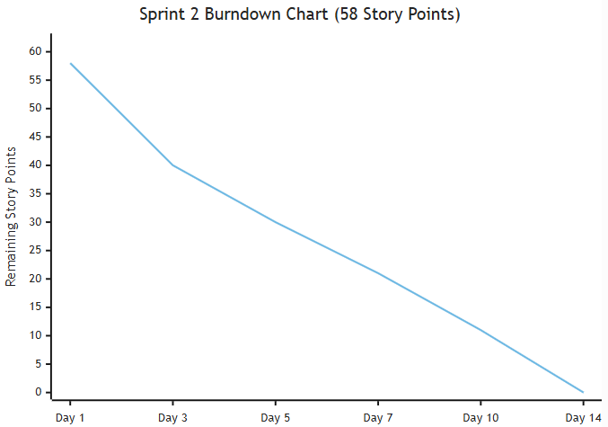
Day | Planned | Completed | Remaining
Day 1 | 0 | 0 | 58
Day 3 | 19 | 18 | 40
Day 5 | 29 | 28 | 30
Day 7 | 38 | 37 | 21
Day 10 | 48 | 47 | 11
Day 14 | 58 | 58 | 0

4.3 Sprint 2 Deliverables
• ✅ Complete loan request and approval system
• ✅ Installment payment functionality
• ✅ Deadline tracking in dashboard
• ✅ Chat system between borrowers and banks
• ✅ Profile pages for all user types
• ✅ Terms and conditions page

5. Sprint 3: Advanced Features & Security
Duration: 2 Weeks (Weeks 7-8)
Sprint Goal: Implement AI/ML security, market data visualization, AI chatbot, and finalize testing & documentation
5.1 Sprint Backlog
Epic 8: Market Data Visualization (8 pts)
ID | Story | Pts
US-3.1 | Market data API — CoinGecko/CoinMarketCap, caching | 3
US-3.2 | Market value graph — Chart.js/Recharts, live + historical | 5

Epic 9: AI Chatbot (13 pts)
ID | Story | Pts
US-3.3 | Chatbot integration — NLP, context-aware responses | 5
US-3.4 | Chatbot training — dataset, intent recognition | 5
US-3.5 | Chatbot features — loan limit, payment, bank contact queries | 3

Epic 10: AI/ML Security Layer (21 pts)
ID | Story | Pts
US-3.6 | ML data collection — transaction logging, feature extraction | 5
US-3.7 | Fraud detection model — risk scoring, loan approval integration | 8
US-3.8 | Anomaly detection — alerts, dashboard | 5
US-3.9 | Security logging — event tracking, bank dashboard | 3

Epic 11: Testing & QA (13 pts)
ID | Story | Pts
US-3.10 | Unit testing — smart contracts, >80% coverage | 5
US-3.11 | Integration testing — E2E, API tests | 5
US-3.12 | Security testing — contract audit, penetration testing | 3

5.2 Sprint 3 Burndown
Total Story Points: 55
Team Velocity: ~27 points per week (estimated)
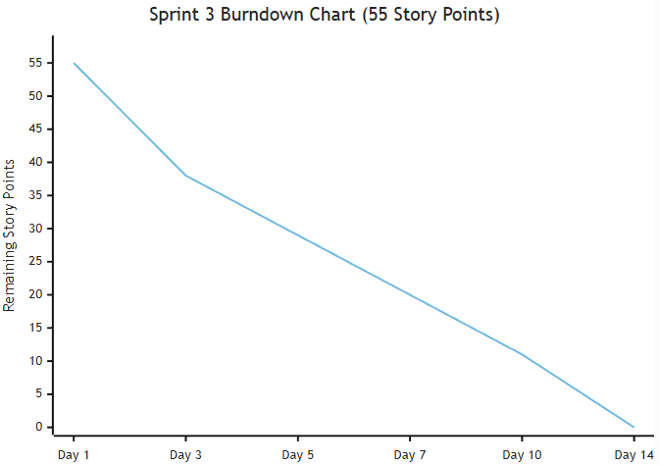
Day | Planned | Completed | Remaining
Day 1 | 0 | 0 | 55
Day 3 | 18 | 17 | 38
Day 5 | 27 | 26 | 29
Day 7 | 36 | 35 | 20
Day 10 | 45 | 44 | 11
Day 14 | 55 | 55 | 0

5.3 Sprint 3 Deliverables
• ✅ Live cryptocurrency market data visualization
• ✅ AI chatbot for user support
• ✅ AI/ML security layer foundation
• ✅ Comprehensive testing suite
• ✅ Security audit completed
5.4 Integration, Testing & Deployment (Weeks 7-8)
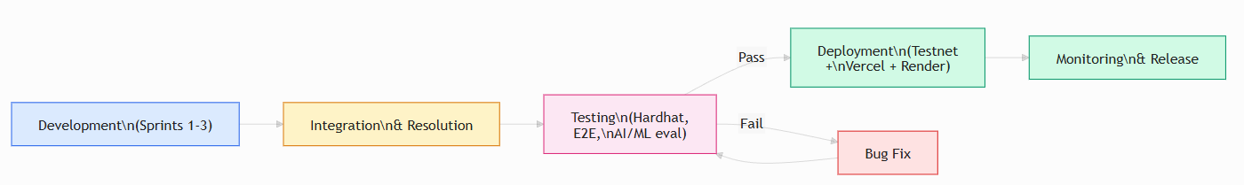
These activities run in parallel with Sprint 3 development:
Integration Activities:
• Integrate all sprint deliverables
• Resolve integration issues
• Performance optimization
Testing Checklist:
• Smart contract functionality (Hardhat unit tests)
• Frontend-backend integration
• Database operations (PostgreSQL)
• Chat system real-time communication (WebSocket)
• Installment payment flow (on-chain)
• AI chatbot responses (NLP pipeline)
• Market data updates (CoinGecko API + Redis cache)
• Security layer monitoring (AI/ML risk scores)
• Mobile responsiveness
• Cross-browser compatibility
Deployment Activities:
• Deploy smart contracts to testnet (Polygon Mumbai / Ethereum Sepolia)
• Deploy frontend (Vercel free tier)
• Deploy backend API (Render free tier)
• Set up monitoring (application and blockchain event listeners)
Release Checklist:
• All features implemented
• All tests passing
• Security audit completed
• Documentation complete
• Production deployment successful
• Monitoring active

5.5 Sprint Story Points Distribution 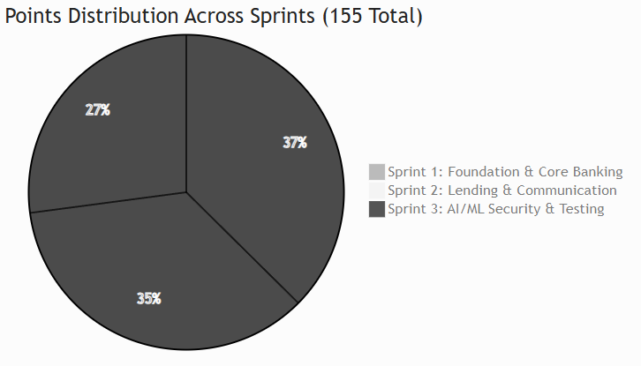
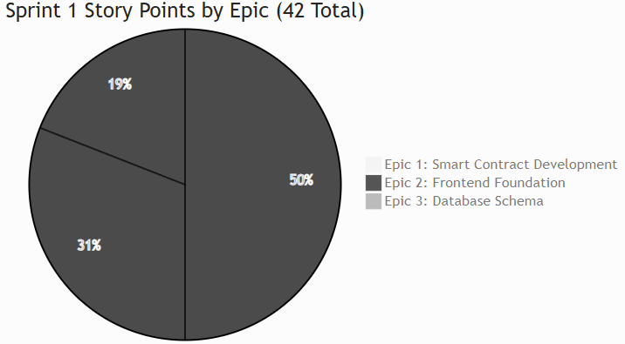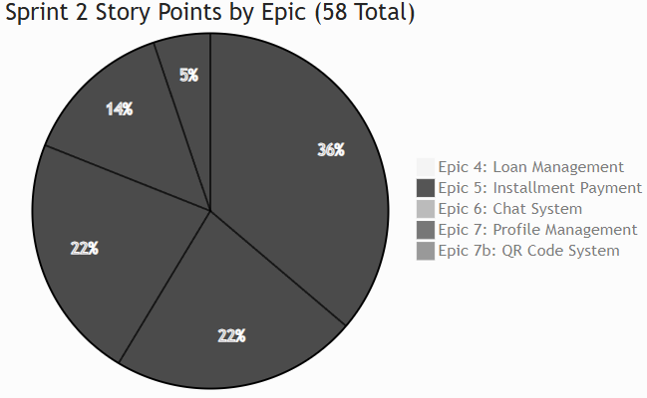
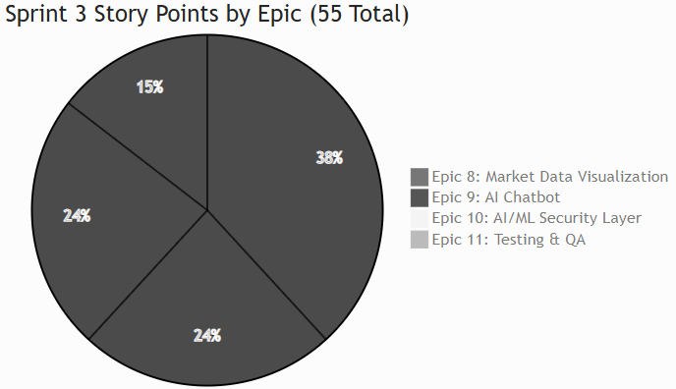

5.6 Agile/Scrum Process Flow
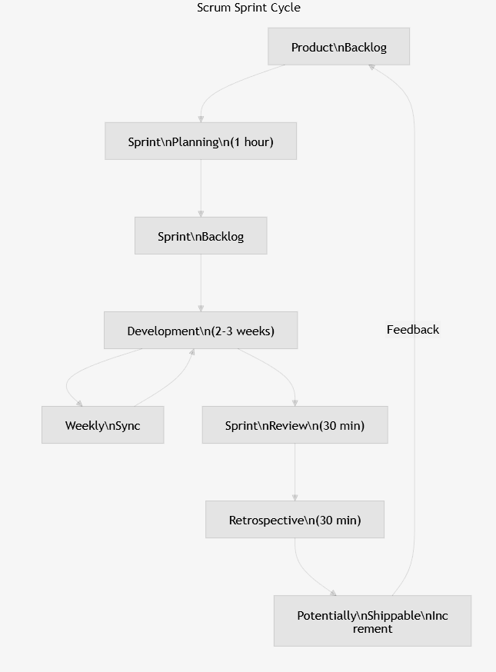
6. Agile Artifacts
6.1 Product Backlog
The complete product backlog includes the condensed user stories (US-1.1 through US-3.12) from sections 3–5, plus additional items for future releases:
Future Features (Post-MVP):
• Multi-cryptocurrency support
• Advanced ML models (LSTM, Transformer)
• Mobile apps (iOS/Android)
• Internationalization (i18n)
• Advanced analytics dashboard
• Automated loan approval using ML
• Credit scoring system
6.2 Sprint Backlog
Each sprint has its own backlog (detailed in sections 3, 4, and 5).
6.3 Definition of Done
A user story is considered "Done" when:
• ✅ Code is written and reviewed
• ✅ Unit tests are written and passing
• ✅ Integration tests are passing
• ✅ Documentation is updated
• ✅ Code is merged to main branch
• ✅ Feature is deployed to staging
• ✅ Product Owner has accepted the story
6.4 Definition of Ready
A user story is "Ready" for sprint planning when:
• ✅ User story is clearly written
• ✅ Acceptance criteria are defined
• ✅ Story points are estimated
• ✅ Dependencies are identified
• ✅ Technical feasibility is confirmed

7. Team Roles & Responsibilities
7.1 Team Structure
This is a 2-person thesis project. Both members share responsibilities across all domains.
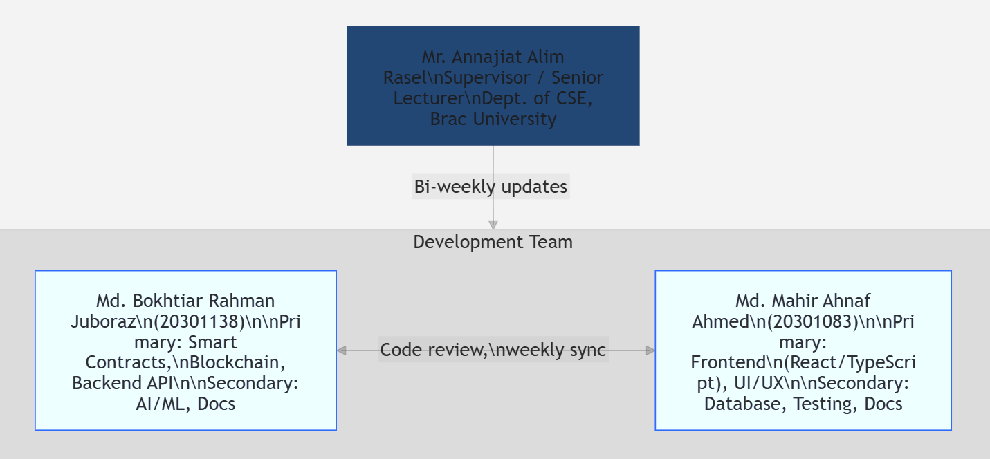
Team Member | Primary Focus | Secondary Focus
Md. Bokhtiar Rahman Juboraz (20301138) | Smart contract development, blockchain integration, backend API | AI/ML model development, documentation
Md. Mahir Ahnaf Ahmed (20301083) | Frontend development (React/TypeScript), UI/UX design | Database design, testing, documentation

Supervisor: Mr. Annajiat Alim Rasel, Senior Lecturer, Dept. of CSE, Brac University
7.2 Collaboration Process
Weekly Sync Format:
1. What was completed this week?
2. What is planned for next week?
3. Are there any blockers or dependency issues?
Code Review: All pull requests reviewed by the other team member before merge.

8. Risk Management
8.1 Identified Risks
Risk | Probability | Impact | Mitigation Strategy
Smart contract vulnerabilities | Medium | High | Security audit, extensive testing
Gas cost fluctuations | High | Medium | Gas optimization, cost estimation
ML model accuracy | Medium | Medium | Continuous training, human review
Integration complexity | Medium | High | Early integration, frequent testing
Scope creep | High | Medium | Strict sprint boundaries, backlog management
Team member unavailability | Low | High | Cross-training, documentation

8.2 Risk Response Plan
• High Priority Risks: Weekly review and mitigation
• Medium Priority Risks: Bi-weekly review
• Low Priority Risks: Monthly review

9. Metrics & KPIs
9.1 Sprint Metrics
• Velocity: Story points completed per sprint
• Burndown: Progress tracking
• Sprint Goal Achievement: % of sprint goal met
9.2 Quality Metrics
• Test Coverage: > 80%
• Bug Density: < 5 bugs per 1000 lines of code
• Code Review Coverage: 100%
9.3 Performance Metrics
• Page Load Time: < 2 seconds
• Transaction Confirmation: < 30 seconds
• API Response Time: < 500ms

10. Communication Plan
10.1 Communication Channels
• Weekly Sync: Progress review, blockers, planning
• Sprint Planning: 1 hour, start of sprint
• Sprint Review: 30 minutes, end of sprint
• Retrospective: 30 minutes, end of sprint
• Supervisor Updates: Bi-weekly
10.2 Tools
• Version Control: GitHub (primary collaboration platform)
• Documentation: Overleaf (LaTeX report), Markdown files in repository
• Communication: In-person meetings, email (professor updates bi-weekly)
• IDE: VS Code with Cursor AI assistant
• CI/CD: GitHub Actions (planned)

11. SDLC Stage Mapping
The Agile sprint structure maps to the standard Software Development Life Cycle (SDLC) stages (ref: [GeeksforGeeks SDLC](https://www.geeksforgeeks.org/software-engineering/software-development-life-cycle-sdlc/)):
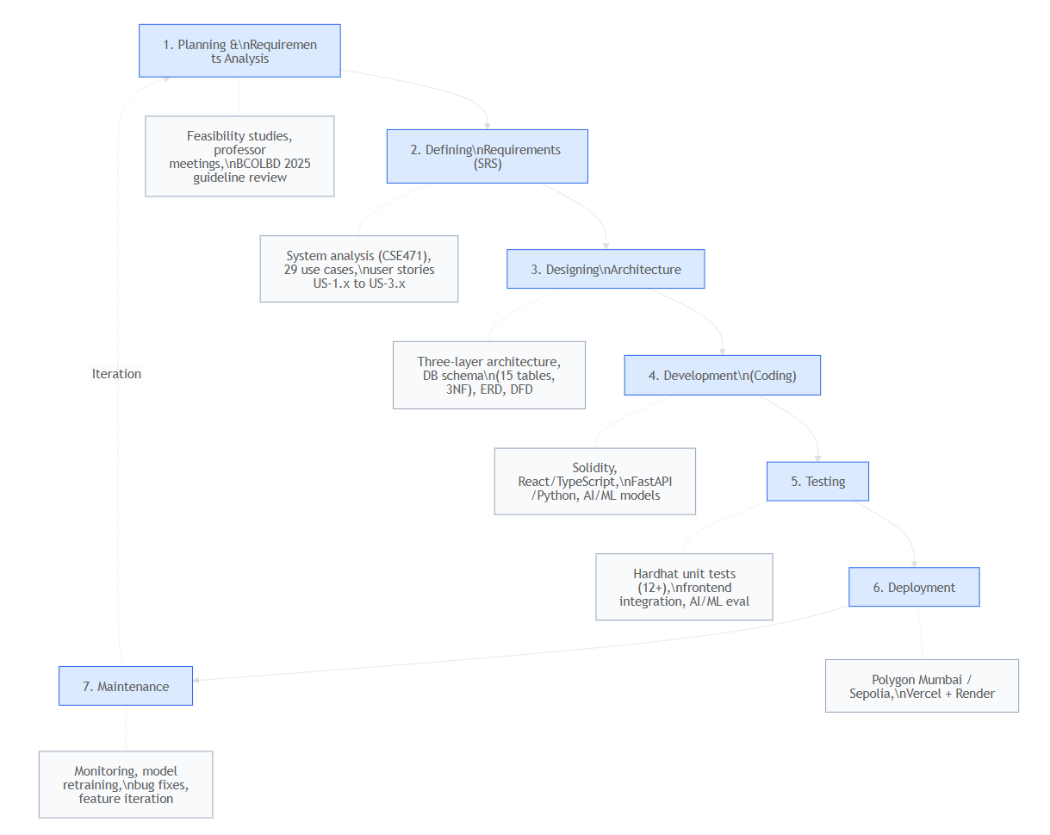
SDLC Stage | Project Activity | Timeline
1. Planning & Requirements Analysis | Feasibility studies (technical, economic, operational, schedule); professor meetings; BCOLBD 2025 guideline review; stakeholder requirement gathering | Pre-Sprint
2. Defining Requirements (SRS) | System analysis (CSE471); use case definitions (29 use cases); non-functional requirements; system constraints; user stories (US-1.x through US-3.x) | Pre-Sprint + Sprint 1
3. Designing Architecture | Three-layer architecture (Presentation, Smart Contract, Off-chain); database schema (15 tables, 3NF); component diagram; data flow diagram; ERD | Sprint 1
4. Development (Coding) | Smart contracts (Solidity), frontend (React/TypeScript), backend (FastAPI/Python), AI/ML models | Sprints 1–3
5. Testing | Hardhat unit tests (12+ tests); frontend integration tests; AI/ML model evaluation; end-to-end testing | Week 7 (Integration & Testing)
6. Deployment | Testnet deployment (Polygon Mumbai / Ethereum Sepolia); frontend on Vercel; backend on Render | Week 8 (Release)
7. Maintenance | Post-deployment monitoring; AI/ML model retraining; bug fixes; feature iteration | Post-Release

12. Design Decisions and Alternatives Considered
Per professor requirement: *"For every decision you take, first present the alternative and then justify your first and second choices."*
The complete decision justification document is maintained in DECISION_JUSTIFICATION_PLAN.md. Summary:
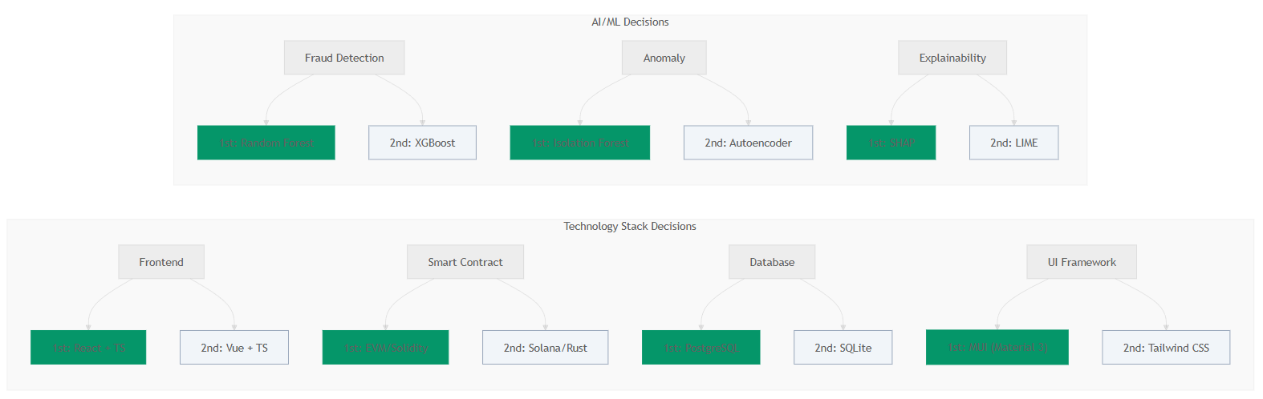
Decision Area | 1st Choice | 2nd Choice | Key Criterion
Development Methodology | Agile / Scrum | Incremental / Spiral | Evolving scope, sprint milestones
Software Architecture | DApp + Off-chain AI | Hybrid with Oracle | Gas cost, ML iteration flexibility
Frontend Framework | React + TypeScript | Vue + TypeScript | Web3 library ecosystem (Wagmi, RainbowKit)
Smart Contract Platform | Ethereum / EVM (Solidity) | Solana (Rust) | Largest ecosystem, free testnets, OpenZeppelin
UI Design System | Material Design 3 (MUI) | Tailwind CSS | Professional banking UI, development speed
Release Cycle | Incremental releases | Continuous deployment | Professor milestones, integration risk
Fraud Detection Algorithm | Random Forest | XGBoost | SHAP compatibility, 94%+ precision
Anomaly Detection | Isolation Forest | Autoencoder | Unsupervised, no labeled data needed
XAI Method | SHAP | LIME | Theoretical foundation, regulatory compliance
Database | PostgreSQL | SQLite | CSE370 alignment, 3NF schema, async support
Hosting / Deployment | Vercel + Render | Localhost | $0 cost, public URL, CI/CD

Each decision includes 2–3 alternatives evaluated, the chosen option with justification, and a backup option with rationale for when it would be preferred. See DECISION_JUSTIFICATION_PLAN.md for full details including criteria analysis.

13. UML and Architecture
13.1 Use Case Diagram
The Use Case diagram is maintained in the CSE471 report. See [Usecase diagram.png](https://github.com/Yuvraajrahman/Cryto-World-Bank/blob/main/Documentation/Diagrams/CSE471/Usecase%20diagram.png) and [CSE471 System Analysis Report §4 Use Case Diagram](https://github.com/Yuvraajrahman/Cryto-World-Bank/blob/main/Documentation/CSE471_SYSTEM_ANALYSIS_AND_DESIGN%20REPORT.md#4-use-case-diagram). It shows actors (Borrower, Bank User, World Bank, National Bank, Local Bank) and 29 use cases.
13.2 Class Diagram (Conceptual)
Component | Classes / Modules
Frontend | `App`, `Layout`, `Pages` (Dashboard, Loan, Deposit, Chat, Profile), `Hooks` (useContract, useUser)
Backend | `routes` (loans, users, blockchain), `services` (blockchain), `database`
Smart Contracts | WorldBankReserve, NationalBank, LocalBank (Solidity)
ML Backend | fraud_detector, anomaly_detector, XAI (SHAP)

Relationships: Frontend → Backend API; Backend → PostgreSQL, Blockchain; Backend → ML API for risk scoring.
13.3 Software Architecture: MVC and Layered
• MVC: React components = View; hooks/state = Controller logic; backend API + DB = Model.
• Layered: Presentation (React) → Application (Node.js/FastAPI) → Data (PostgreSQL, blockchain).
• Client-Server: Frontend (client) ↔ Backend (server); Backend ↔ Blockchain nodes.

14. Design Patterns
Pattern | Usage
Singleton | Contract instances (useContract), Wagmi/Web3 config — single shared instance
Observer | React state, blockchain event listeners — components react to data changes
Adapter | Wagmi/viem adapts different wallet providers (MetaMask, WalletConnect) to a common interface

15. Software Testing and Metrics
15.1 Testing
• Unit tests: Hardhat for smart contracts; Jest/Vitest for frontend/backend (planned).
• Integration: API tests, E2E (Playwright/Cypress) for critical flows.
15.2 Software Metrics
Metric | Target | Notes
Cyclomatic Complexity | < 10 per function | Reduces branching; complex logic split into smaller functions
CFG (Control Flow Graph) | Used for test path coverage | Each branch in conditionals adds paths
Test Coverage | > 80% | Smart contracts; frontend/backend in progress

16. Effort Estimation and Project Scheduling
16.1 COCOMO (Simplified)
• Mode: Organic (small team, familiar domain).
• Size: ~15–20 KLOC (frontend + backend + contracts + ML).
• Effort: E = a × (KLOC)^b; a=2.4, b=1.05 → ~35–45 person-months nominal; scaled down for 2-person, 2-month → ~4 person-months equivalent for prethesis scope.
16.2 CPM (Critical Path Method)
Critical path: Smart Contracts → Wallet Integration → Loan Flow → AI/ML Integration → Testing. Longest dependency chain; delays here directly impact release. Non-critical: Market data, QR codes, profile polish can slip without blocking core delivery.
16.3 Refactoring
Refactoring is applied during sprint retrospectives: extract reusable hooks, consolidate API routes, simplify contract modifiers. No large-scale refactor planned; incremental improvements as technical debt is identified.

17 Prototype Demonstration:
The following screenshots show the Crypto World Bank prototype in action:
Figure 1: Dashboard Overview

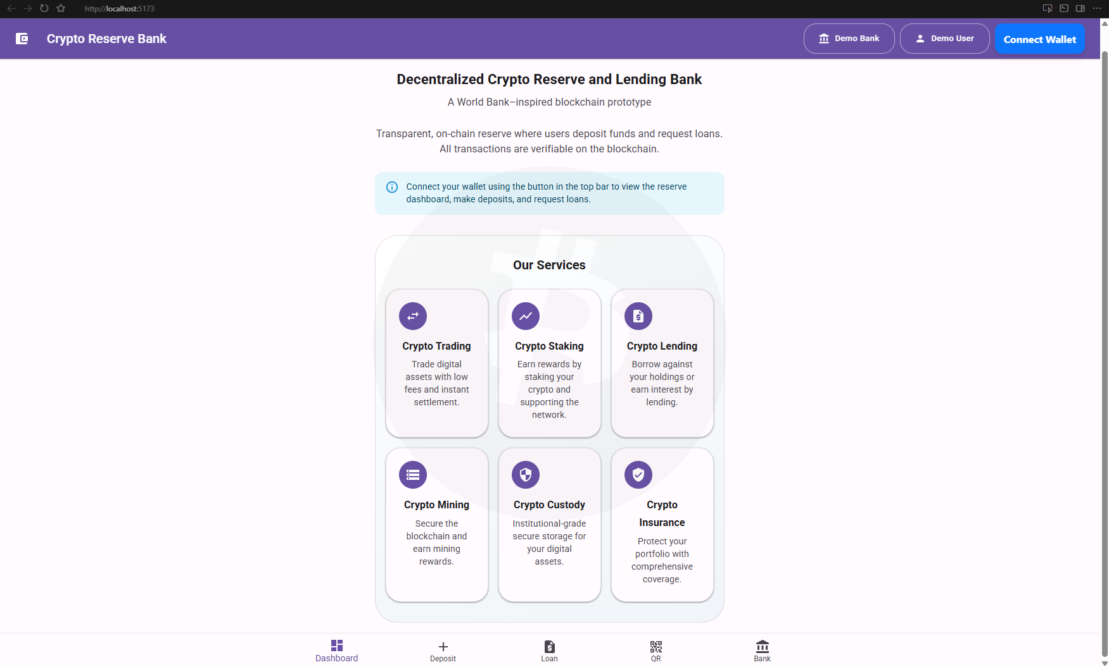
Figure 2: Lending Interface
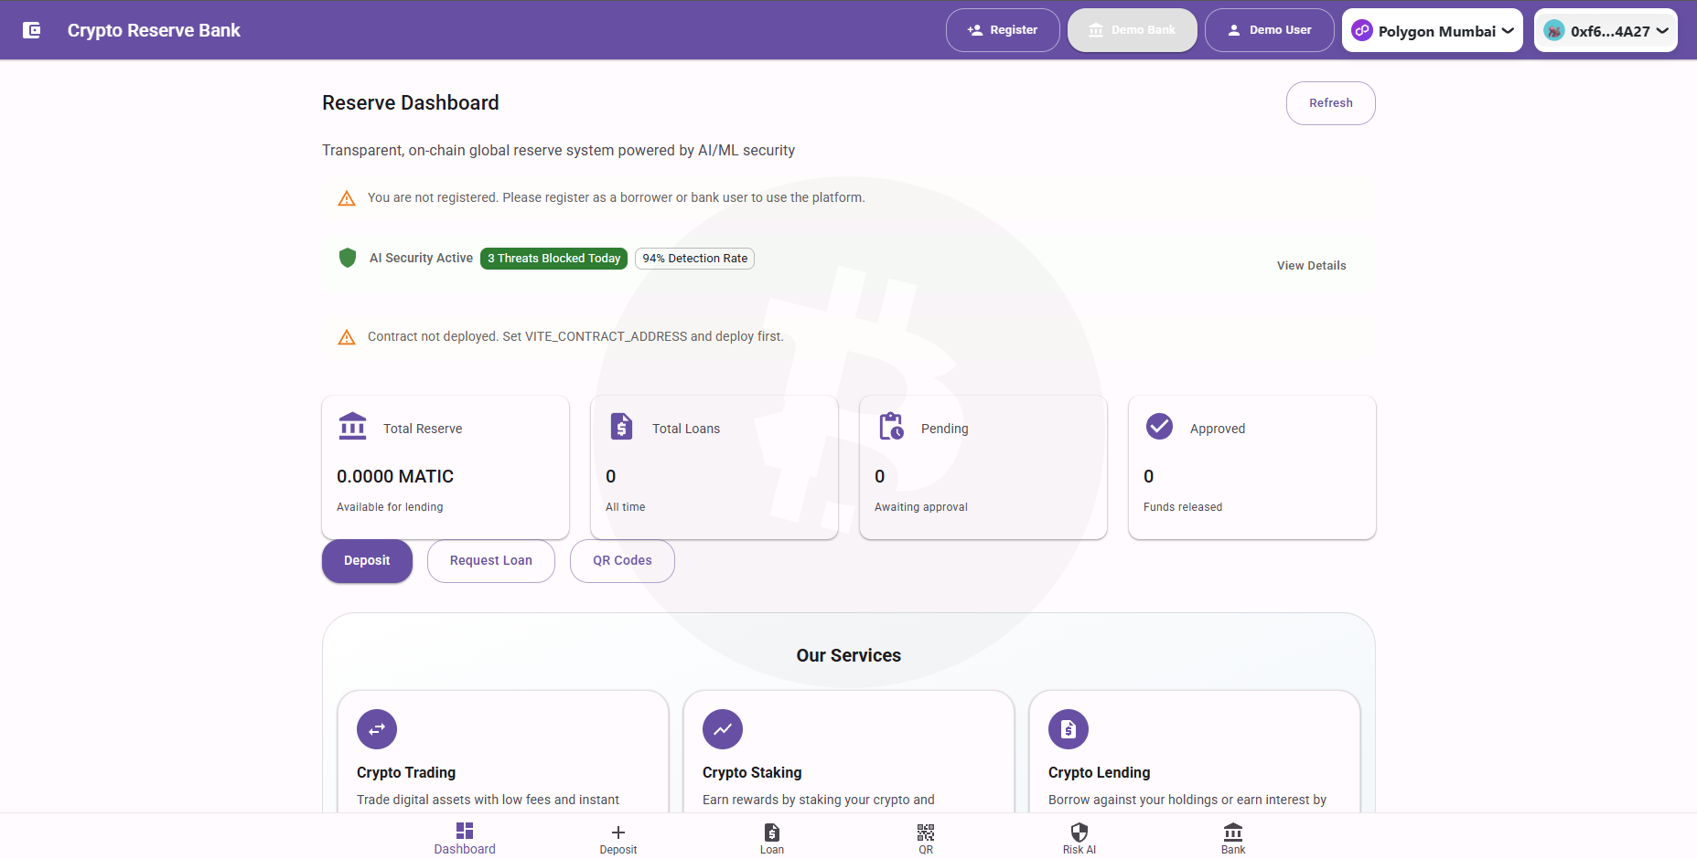
Figure 3: Transaction & Chat
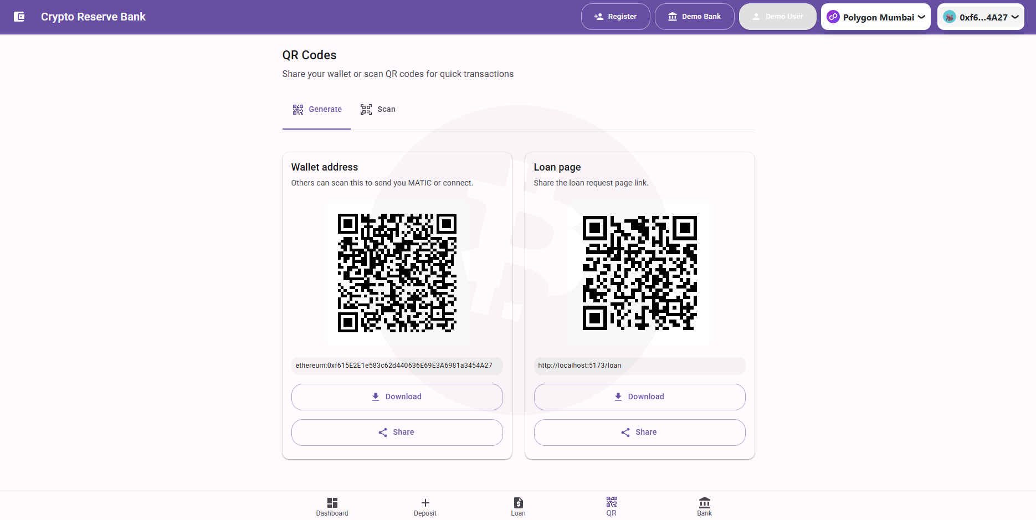
Figure 4: Profile & Settings
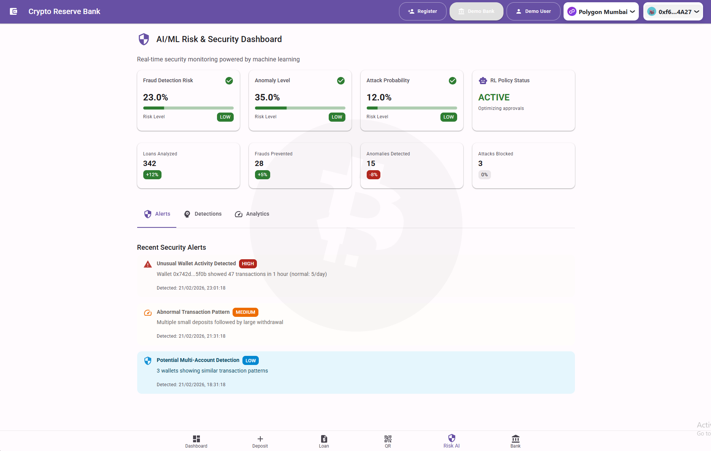

18. Conclusion
This Agile development plan provides a structured approach to building the Crypto World Bank platform over 2 months with 3 sprints (Prethesis 1 scope). The methodology ensures:
• Incremental delivery of features aligned with SDLC stages
• Continuous feedback and improvement through sprint reviews
• Risk mitigation through early testing and integration
• Justified design decisions with documented alternatives
• Quality assurance throughout development
The plan is flexible and can be adjusted based on team velocity and changing requirements.

Document Version: 3.1
Last Updated: February 2026
Author: Software Engineering Team
Course: CSE470 - Software Engineering

